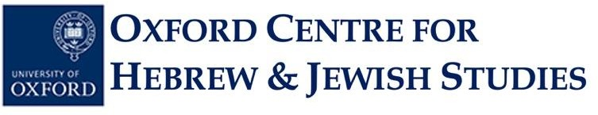
OXFORD SCHOOL OF RARE JEWISH LANGUAGES STUDENT
APPLICATION FORM, 2023-24

JEWISH MUSIC COURSE

INTRODUCTION TO THE HISTORY OF YIDDISH MUSIC

Trinity Term 2024:
From Resistance to New Voices: Yiddish Music from Wartime to the 21st Century

Tutor: Dr Diana Matut
Online course via Zoom on Mondays 18:15 to 19:15 (UK time)

Note: The number of places available for this music class is limited. Priority will be given to applicants who are current university students, but other candidates will be considered. This class is free of charge.

Surname: ……………………………………………………………………………………………...

Forename(s): . . . . . . . . . . . . . . . . . . . . . . . . . . . . . . . . . . . . . . . . . . . . . . . . . . . ………………………

Email Address: . . . . . . . . . . . . . . . . . . . . . . . . ……………………………………………………....

Postal Address: ……………………………………………………………………………………..

…………………………………………………………………………………………………………

Contact Phone Number: . . . . . . ……………………………………………………………………………….

Education (current or previous school[s]/university[ies], degree level[s] and subject area[s], graduation date[s]):

………………………………………………………………………………………………………………………

……………………………………………………………………………………………………………………….

Please submit your completed application form as a Word document to the OCHJS Academic Administrator, Ms Priscilla Lange, by email at academic.administrator@ochjs.ac.uk no later than Sunday 5th May 2024.

Individuals whose applications are successful will be notified on Monday 6th May 2024. The first day of class for this course will be Monday, 6th May 2024. Please note that this course will continue to be taught until Monday, 24th June, two weeks after Trinity Term officially ends.

University of Oxford dates of term are as follows:
Michaelmas 2023: Sunday 8 October-Saturday 2 December
Hilary 2024: Sunday 14 January-Saturday 9 March
Trinity 2024: Sunday 21 April-Saturday 15 June

***************************************************************************************************************

Trinity Term 2024:
From Resistance to New Voices: Yiddish Music from Wartime to the 21st Century

Mondays, 18:15-19:15 UK Time, Online via Zoom

In this year-long course about the history of Yiddish vernacular music we have so far explored its beginnings from the Medieval period to the time of inner and outer globalization and internationalization up to 1933.

This last term of the academic year will predominantly explore the Jewish experience in Yiddish song but also the complete change in paradigms such as social contexts, fusions, post-vernacularity and performance practice.

Students are welcome to join this course on the History of Yiddish Music for any of the three terms. It is not necessary to take them all consecutively.

Applications will remain open until Sunday, 6th May 2024 no later than 12 noon UK time (You can check time-zone comparisons on sites such as this one).

Individuals whose applications are successful will be notified on Monday, 6th May 2024.

The first day of class for this course will be Monday, 6th May 2024 (Week 3). Please note that this course will continue to be taught until Monday, 24th June, two weeks after Trinity Term officially ends.

