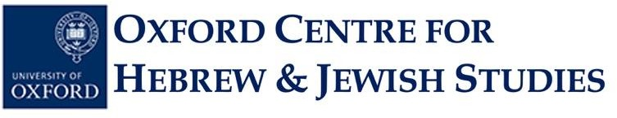
OXFORD SCHOOL OF RARE JEWISH LANGUAGES STUDENT
APPLICATION FORM, 2024-25

JEWISH MUSIC COURSE

YIDDISH MUSICS: THE 20TH AND 21ST CENTURY

Michaelmas Term 2024:

Tutor: Dr Diana Matut
Online course via Zoom on Mondays 18:15 to 19:15 (UK time)

Note: The number of places available for this music class is limited. Priority will be given to applicants who are current university students, but other candidates will be considered. This class is free of charge.

Surname: ……………………………………………………………………………………………...

Forename(s): . . . . . . . . . . . . . . . . . . . . . . . . . . . . . . . . . . . . . . . . . . . . . . . . . . . ………………………

Email Address: . . . . . . . . . . . . . . . . . . . . . . . . ……………………………………………………....

Postal Address: ……………………………………………………………………………………..

…………………………………………………………………………………………………………

Contact Phone Number: . . . . . . ……………………………………………………………………………….

Education (current or previous school[s]/university[ies], degree level[s] and subject area[s], graduation date[s]):

………………………………………………………………………………………………………………………

……………………………………………………………………………………………………………………….

Please submit your completed application form as a Word document to the OCHJS Academic Administrator, Ms Priscilla Lange, by email at academic.administrator@ochjs.ac.uk no later than Thursday 10th October 2024 at 12 noon (Oxford time).

Individuals whose applications are successful will be notified on Thursday 10th October 2024. The first day of class for this course will be Monday, 14th October 2024.

University of Oxford dates of term are as follows:
Michaelmas 2024: Sunday 13 October-Saturday 7 December
Hilary 2025: Sunday 19 January-Saturday 15 March
Trinity 2025: Sunday 27 April-Saturday 21 June

***************************************************************************************************************

Michaelmas Term 2024:
Yiddish Musics: The 20th and 21st Century

Mondays, 18:15-19:15 UK Time, Online via Zoom

This course focusses on the development of Yiddish musics mainly after Second World War.

The entire spectrum of Yiddish (mainly vocal) music making will be considered and organized according to topics such as: nostalgia, belonging and uprootedness; building the canon of Yiddish song performances; contemporary song cultures and cultural translations; Yiddish film music and music in Yiddish films; Yiddish activism; inner-Hasidic developments (women’s, religious and children’s songs); new Yiddish opera and theatre song - to name but a few.

This year-long course will also include the possibility for participant observation while exploring strategies of Yiddish song writing and/or song translations from or into Yiddish. It will explore, question and debate the “post” of “post vernacular” and “postmodernity”.

We will also welcome at least one guest per term. Invited are song writers, musicians and Yiddish activists.

Knowledge of Yiddish is helpful, but not required to take this course.

Applications will remain open until Thursday, 10th October 2024 no later than 12 noon UK time (You can check time-zone comparisons on sites such as this one).

Individuals whose applications are successful will be notified on Thursday, 10th October 2024.

The first day of class for this course will be Monday, 14th October 2024 (Week 1).

